**New year’s Eve**

**up , out, turnout, sold, turn**

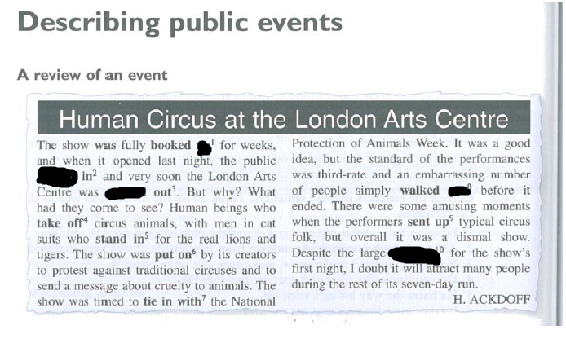

up, turn, sold, out, turnout

**tipsy, flood , surpass (przekroczyć), vivid (obrazowy, bujny) , mixed , plastered, appeal, whale, overwhelmed (pod wrażeniem), jaw-dropping (oszałamiający), light up (odpalać), squeeze (ścisk), scatter (rozproszyć się), buzzing (szalony, huczny), beverages (drinki alkoholowe i bezalkoholowe), wild , resolutions**

A lot of people were …plastered……………………after New Year’s eve party .

That performance was extraordinary it ……surpassed………………my expectations

I …appeal……………………New Year as I hope it will be more promising , prosperous and abundant in

When you …light up……….fireworks you need to cautious not to burn your hands

I have ……mixed………………………….feelings about that concert It didn’t blow me away. It was ok

The band didn’t …appeal…………………to me personally . It was not my cup of tea

That New Year’s Eve was ……jaw-dropping……………..and ……buzzling…………… I was a bit …tipsy………….after few shots. Some of my friends got ……wild………..

I was……overwhelmed…………………………………by massive fireworks

We had a lot of…beverages…………………………… during New Year’s Eve including , whiskey , champagne and soft drinks,

How many …resolutions……………………….have you made for upcoming New Year

I had a …whale……………………………of time at a ball It was stunning

Display of fireworks in London was …vivid………………………………., absolutely spectacular

People …flooded………………………………….into the market square to watch the concert . After the concert they …scattered………………………..in all directions . There was such a ……squeeze…………………………….that I couldn’t breathe

Phrasal verbs – entertainment

up**, off , up , up , up , into , round,** up **, out,** along**,** off

Our friends brought their family along……………….. to our house during New Year’s Eve

That party didn’t live …up……………………..to my expectations . It was below substandard and dull

Our plan of going out that evening didn’t come …off…………………………….due to my husband’s illness

Crowds of people , frost as well as drunkards turn me ……………………………..that’s why I prefer to stay at home

I couldn’t put…up……………………with her voice so I turned off TV

Are you ……………………….for New Year’s Eve party?

Celebration kicked…off…………………….at 8 p.m

Fireworks lit …………………………….the sky

Next year I don’t rule……off…………………………going abroad during New Year’s Eve

If you mishandle fireworks you may burn …………………………..your hands

Some friends came ……………………………..to welcome New Year together